Election

## 1. Load Packages

library(readr)  
library(ggplot2)  
library(gridExtra) # For multiple plots  
library(dplyr)  
library(tidyr)

## 2. Read the dataset

set.seed(1117)  
  
election_data <- read.csv("census_parlimen.csv")  
  
# N is the number of voters  
# Y is the number of voters who support the government  
# Notable Score is where that seat is contested by a famous politician  
election_data$seat <- as.integer(election_data$seat)  
election_data$region <- as.factor(election_data$region)  
election_data$N <- as.integer(election_data$N)  
election_data$Y <- as.integer(election_data$Y)  
election_data$malay_prop <- as.numeric(election_data$malay_prop)  
election_data$indian_prop <- as.numeric(election_data$indian_prop)  
election_data$chinese_prop <- as.numeric(election_data$chinese_prop)  
election_data$notable_score <- as.integer(election_data$notable_score)  
  
# Extract number of seats and regions  
C <- nrow(election_data)  
R <- length(unique(election_data$region))  
  
print(C)

[1] 222

print(R)

[1] 13

head(election_data)

seat region state parlimen code_parlimen N Y prop  
1 1 1 Perlis P.001 Padang Besar P.001 35520 21473 0.6045327  
2 2 1 Perlis P.002 Kangar P.002 42649 23343 0.5473282  
3 3 1 Perlis P.003 Arau P.003 37787 19376 0.5127689  
4 4 2 Kedah P.004 Langkawi P.004 31133 21407 0.6875984  
5 5 2 Kedah P.005 Jerlun P.005 45052 24161 0.5362914  
6 6 2 Kedah P.006 Kubang Pasu P.006 56224 33334 0.5928785  
 previous_result malay_prop chinese_prop indian_prop notable_score pred_prob  
1 1 0.8601 0.0814 0.0088 1 0.6031824  
2 1 0.8158 0.1473 0.0157 0 0.5445903  
3 1 0.8723 0.0781 0.0159 0 0.5120035  
4 1 0.8965 0.0675 0.0238 0 0.5318187  
5 1 0.9075 0.0678 0.0011 0 0.5382606  
6 1 0.8599 0.0872 0.0338 1 0.6075472  
 pred_votes pred_win  
1 21419 1  
2 23310 1  
3 19531 1  
4 16559 1  
5 24261 1  
6 34558 1

## 3. Define Logistic Regression Log-Posterior

Assuming all priors and hyperpriors are normally distributed:

$$
p(\eta \mid y) \propto p(y \mid \eta = \beta_0, \beta_{Ethnic,Region},\beta_{Notable}) \cdot p(\beta_{Ethnic,Region} \mid \mu_{Ethnic},\tau_{Ethnic}) \cdot p(\mu_{Ethnic}) \\ \cdot p(\beta_0) \cdot p(\beta_{Notable})
\cdot p(\tau_{Ethnic})
\\
\ln p(\eta \mid y) \propto \ln p(y \mid \eta = \beta_0, \beta_{Ethnic,Region},\beta_{Notable}) + \ln p(\beta_{Ethnic,Region} \mid \mu_{Ethnic},\tau_{Ethnic}) \\ + \ln p(\mu_{Ethnic}) + \ln p(\beta_0) + \ln p(\beta_{Notable}) +
\ln p(\tau_{Ethnic})
$$

The model distribution (Logistic Regression with Logit Link):

$$
f_i = p_i^{Y_i} \cdot (1-p_i)^{N_i - Y_i} \\
\ell_i = Y_i \cdot ln(p_i) + (N_i - Y_i) \cdot ln(1 - p_i) \\
\ell_i =Y_i \cdot \ln\!\left(\frac{e^{\eta_i}}{1 + e^{\eta_i}}\right) +
(N_i - Y_i) \cdot \ln\!\left(\frac{1}{1 + e^{\eta_i}}\right) \\
\ell_i =
Y_i \cdot \left[-\ln\!\left(1 + e^{-\eta_i}\right)\right] +
\left(N_i - Y_i\right) \cdot \left[-\ln\!\left(1 + e^{\eta_i}\right)\right]
$$

The log-prior for intercept and beta_notable (Normally distributed with mean 0 and standard deviation 2):

$$
p(\beta) = \frac{1}{\sqrt{2\pi\sigma^2}} \exp\!\left(-\frac{(\beta-\mu)^2}{2\sigma^2}\right) \\
\text{Zero mean and dropping multiplicative constant}(\mu=0): \\
p(\beta) = \exp\!\left(-\frac{\beta^2}{2\sigma^2}\right) \\
\ln p(\beta) = - \!\left(\frac{\beta^2}{2\sigma^2}\right) \\
$$

The log-prior for region and ethnic-specific slope:

$$
p(\beta_{Ethnic,Region_i}) = \frac{1}{\sqrt{2\pi\sigma^2}}
\exp\!\left(-\frac{(\beta_{Ethnic,Region_i}-\mu_{Ethnic})^2}{2\tau_{Ethnic}^2}\right) \\
\ln p(\beta_{Ethnic,Region_i}) = - \!\left(\frac{(\beta_{Ethnic,Region_i}
- \mu_{Ethnic})^2}{2\tau_{Ethnic}^2}\right) \\
$$

The hyperprior of mu ethnic is normal distribution with mean 0 and standard deviation of 5:

$$
\ln p(\mu_{Ethnic}) = - \!\left(\frac{\mu_{ethnic}^2}{2\sigma^2}\right) \\
$$

The hyperprior of tau follows a half-cauchy distribution with scale parameter 2:

$$f\left(τ_{Ethnic}∣σ\right)=\frac{2}{π σ \left(1+{\left(\frac{τ_{Ethnic}}{σ}\right)}^{2}\right)}, τ≥0$$

log_posterior_hier <- function(beta0, beta_notable,  
 beta_malay_r, beta_indian_r, beta_chinese_r,  
 mu_malay, mu_indian, mu_chinese, election_data,  
 prior_sd_beta0 = 2,  
 prior_sd_notable = 2,  
 scale, tau_malay, tau_indian, tau_chinese,  
 prior_sd_mu = 5) {  
   
 # The number of voters, the number of supporters of the BN goverment and ethnicity proportion of 222 constituencies  
 N_vec <- election_data$N  
 Y_vec <- election_data$Y  
 x_malay <- election_data$malay_prop  
 x_indian <- election_data$indian_prop  
 x_chinese <- election_data$chinese_prop  
 x_notable <- election_data$notable_score  
 region_id <- as.integer(election_data$region)  
   
 # 1) Log-likelihood of the model distribution   
 # eta is the systematic component  
 eta <- numeric(length(Y_vec))  
 for (i in seq_along((Y_vec))) {  
 r <- region_id[i]  
 eta[i] <- beta0 + beta_notable * x_notable[i] +  
 beta_malay_r[r] * x_malay[i] +  
 beta_indian_r[r] * x_indian[i] +  
 beta_chinese_r[r] * x_chinese[i]  
 }  
   
 # Individual Log-likelihood function for a single data point  
 # log1p(x) = ln(1+x)  
 loglik_i <- Y_vec * (-log1p(exp(-eta))) +  
 (N_vec - Y_vec) * (-log1p(exp(eta)))  
   
 # All data points  
 loglik <- sum(loglik_i)  
   
 # 2) Priors on β0 and β_notable  
 logprior_beta0 <- - (beta0^2) / (2 * prior_sd_beta0^2)  
 logprior_notable <- - (beta_notable^2) / (2 * prior_sd_notable^2)  
   
 # 3) Priors on region-specific slopes  
 logprior_malay_r <- - sum((beta_malay_r - mu_malay)^2) / (2 * tau_malay^2)  
 logprior_indian_r <- - sum((beta_indian_r - mu_indian)^2) / (2 * tau_indian^2)  
 logprior_chinese_r <- - sum((beta_chinese_r - mu_chinese)^2) /   
 (2 * tau_chinese^2)  
   
 # 4) Hyperprior of prior mean  
 logprior_mu_malay <- - (mu_malay^2) / (2 * prior_sd_mu^2)  
 logprior_mu_indian <- - (mu_indian^2) / (2 * prior_sd_mu^2)  
 logprior_mu_chinese <- - (mu_chinese^2) / (2 * prior_sd_mu^2)  
   
 # 5) Hyperprior of tau_ethnic  
 if (tau_malay <= 0) {  
 logprior_tau_malay <- -Inf  
 } else {  
 logprior_tau_malay <- log(2) - log(pi * scale * (1 + (tau_malay/scale)^2))  
 }  
   
 if (tau_indian <= 0) {  
 logprior_tau_indian <- -Inf  
 } else {  
 logprior_tau_indian <- log(2) - log(pi * scale * (1 + (tau_indian/scale)^2))  
 }  
   
 if (tau_chinese <= 0) {  
 logprior_tau_chinese <- -Inf  
 } else {  
 logprior_tau_chinese <- log(2) - log(pi * scale * (1 + (tau_chinese/scale)^2))  
 }  
   
 # Combine all components  
 return(loglik +  
 logprior_beta0 + logprior_notable +  
 logprior_malay_r + logprior_indian_r + logprior_chinese_r +  
 logprior_mu_malay + logprior_mu_indian + logprior_mu_chinese +  
 logprior_tau_malay + logprior_tau_indian + logprior_tau_chinese)  
}

## 4. Metropolis-Hasting Algorithm

We will use Normal Distribution as the proposal distribution.

set.seed(1)  
  
n_iter <- 2500  
burn_in <- 1500  
prior_sd_beta0 <- 2  
prior_sd_notable<- 2  
prior_sd_mu <- 5  
scale <- 2  
  
# This will determine the strength of random jump  
sigma_beta0 <- 0.01  
sigma_mu <- 0.30  
sigma_region <- 0.01  
sigma_tau <- 0.30  
  
R <- length(unique(election_data$region))  
chain <- matrix(0, nrow = n_iter, ncol = 2 + 3*R + 3 + 3)  
colnames(chain) <- c(  
 "beta0", "beta_notable",  
 paste0("beta_malay_r", 1:R),  
 paste0("beta_indian_r", 1:R),  
 paste0("beta_chinese_r", 1:R),  
 "mu_malay", "mu_indian", "mu_chinese",  
 "tau_malay", "tau_indian", "tau_chinese"  
)  
  
# Initial Starting Values  
chain[1, ] <- c(0, 0, rep(0, 3*R), 0, 0, 0, 1, 1 ,1)  
  
# Calculate log-likelihood at initial point, we will update this after new parameter are accepted  
initial_beta0 <- chain[1, "beta0"]  
initial_beta_notable <- chain[1, "beta_notable"]  
initial_beta_malay_r <- chain[1, paste0("beta_malay_r", 1:R)]  
initial_beta_indian_r <- chain[1, paste0("beta_indian_r", 1:R)]  
initial_beta_chinese_r <- chain[1, paste0("beta_chinese_r", 1:R)]  
initial_mu_malay <- chain[1, "mu_malay"]  
initial_mu_indian <- chain[1, "mu_indian"]  
initial_mu_chinese <- chain[1, "mu_chinese"]  
initial_tau_malay <- chain[1, "tau_malay"]  
initial_tau_chinese <- chain[1, "tau_chinese"]  
initial_tau_indian <- chain[1, "tau_indian"]  
  
logpost_curr <- log_posterior_hier(  
 beta0 = initial_beta0,  
 beta_notable = initial_beta_notable,  
 beta_malay_r = initial_beta_malay_r,  
 beta_indian_r = initial_beta_indian_r,  
 beta_chinese_r = initial_beta_chinese_r,  
 mu_malay = initial_mu_malay,  
 mu_indian = initial_mu_indian,  
 mu_chinese = initial_mu_chinese,  
 election_data = election_data,  
 prior_sd_beta0 = prior_sd_beta0,  
 prior_sd_notable = prior_sd_notable,  
 scale = scale,  
 tau_malay = initial_tau_malay,  
 tau_chinese = initial_tau_chinese,  
 tau_indian = initial_tau_indian,  
 prior_sd_mu = prior_sd_mu  
)  
  
# Track Acceptance  
move_beta0 <- logical(n_iter) # for block 1  
move_region <- array(FALSE, dim = c(n_iter, 3, R)) # for block 2  
move_mu <- logical(n_iter) # for block 3  
move_tau <- logical(n_iter) # for block 4  
  
# Main Loop  
for (t in 2:n_iter) {  
 # Block 1: Update Beta 0 and Beta Notable  
 # The original value + The random jump  
 prev_beta0 <- chain[t - 1, "beta0"]  
 prev_beta_notable <- chain[t - 1, "beta_notable"]  
 prop2 <- c(prev_beta0, prev_beta_notable) + rnorm(2, mean = 0, sd = sigma_beta0)  
 prop_beta0 <- prop2[1]  
 prop_beta_notable <- prop2[2]  
   
 prev_beta_malay_r <- as.numeric(chain[t - 1, paste0("beta_malay_r", 1:R)])  
 prev_beta_indian_r <- as.numeric(chain[t - 1, paste0("beta_indian_r", 1:R)])  
 prev_beta_chinese_r <- as.numeric(chain[t - 1, paste0("beta_chinese_r", 1:R)])  
 prev_mu_malay <- chain[t - 1, "mu_malay"]  
 prev_mu_indian <- chain[t - 1, "mu_indian"]  
 prev_mu_chinese <- chain[t - 1, "mu_chinese"]  
 prev_tau_malay <- chain[t - 1, "tau_malay"]  
 prev_tau_indian <- chain[t - 1, "tau_indian"]  
 prev_tau_chinese <- chain[t - 1, "tau_chinese"]  
  
 logpost_prop_1 <- log_posterior_hier(  
 beta0 = prop_beta0,  
 beta_notable = prop_beta_notable,  
 beta_malay_r = prev_beta_malay_r,  
 beta_indian_r = prev_beta_indian_r,  
 beta_chinese_r = prev_beta_chinese_r,  
 mu_malay = prev_mu_malay,  
 mu_indian = prev_mu_indian,  
 mu_chinese = prev_mu_chinese,  
 election_data = election_data,  
 prior_sd_beta0 = prior_sd_beta0,  
 prior_sd_notable = prior_sd_notable,  
 scale = scale,  
 tau_malay = prev_tau_malay,  
 tau_chinese = prev_tau_chinese,  
 tau_indian = prev_tau_indian,  
 prior_sd_mu = prior_sd_mu  
 )  
   
 # The core of this algorithm is that if the improvement in log-likelihood under the new parameter settings then the higher the chance we accept it  
 log_r1 <- logpost_prop_1 - logpost_curr  
 if (log(runif(1)) < log_r1) {  
 # Write in the new values  
 chain[t, "beta0"] <- prop_beta0  
 chain[t, "beta_notable"] <- prop_beta_notable  
   
 # If the new setting is adopted, the value of the log-likelihood function has to be updated  
 logpost_curr <- logpost_prop_1  
 # Record  
 move_beta0[t] <- TRUE  
 } else {  
 chain[t, "beta0"] <- prev_beta0  
 chain[t, "beta_notable"] <- prev_beta_notable  
 move_beta0[t] <- FALSE  
 }  
   
 new_beta0 <- chain[t, "beta0"]  
 new_beta_notable <- chain[t, "beta_notable"]  
   
   
 # Block 2: Update each region specific slope:  
 # We will use for loop to update the slope of each region for each ethnicity  
 # 2A) Slope of Malay of each region:  
 for (r in 1:R) {  
 bmr_old <- prev_beta_malay_r[r]  
 bmr_prop <- bmr_old + rnorm(1, mean = 0, sd = sigma_region)  
   
 # We have I regions, we kept other I - 1 the same except for the one under the loop  
 prop_beta_malay_r <- prev_beta_malay_r  
 prop_beta_malay_r[r] <- bmr_prop  
   
 # Shall use the latest updated parameter (Intercept and beta_notable)  
 logpost_prop_2a <- log_posterior_hier(  
 beta0 = new_beta0,  
 beta_notable = new_beta_notable,  
 beta_malay_r = prop_beta_malay_r,  
 beta_indian_r = prev_beta_indian_r,  
 beta_chinese_r = prev_beta_chinese_r,  
 mu_malay = prev_mu_malay,  
 mu_indian = prev_mu_indian,  
 mu_chinese = prev_mu_chinese,  
 election_data = election_data,  
 prior_sd_beta0 = prior_sd_beta0,  
 prior_sd_notable = prior_sd_notable,  
 scale = scale,  
 tau_malay = prev_tau_malay,  
 tau_chinese = prev_tau_chinese,  
 tau_indian = prev_tau_indian,  
 prior_sd_mu = prior_sd_mu  
 )  
   
 log_r2a <- logpost_prop_2a - logpost_curr  
 if (log(runif(1)) < log_r2a) {  
 chain[t, paste0("beta_malay_r", r)] <- bmr_prop  
 logpost_curr <- logpost_prop_2a  
 move_region[t, 1, r] <- TRUE  
 } else {  
 chain[t, paste0("beta_malay_r", r)] <- bmr_old  
 move_region[t, 1, r] <- FALSE  
 }  
 }  
   
 new_beta_malay_r <- as.numeric(chain[t, paste0("beta_malay_r", 1:R)])   
   
 # 2B) Slope of Indian of each region  
 for (r in 1:R){  
 bir_old <- prev_beta_indian_r[r]  
 bir_prop <- bir_old + rnorm(1, mean = 0, sd = sigma_region)  
 prop_beta_indian_r <- prev_beta_indian_r  
 prop_beta_indian_r[r] <- bir_prop  
   
 logpost_prop_2b <- log_posterior_hier(  
 beta0 = new_beta0,  
 beta_notable = new_beta_notable,  
 beta_malay_r = new_beta_malay_r,  
 beta_indian_r = prop_beta_indian_r,  
 beta_chinese_r = prev_beta_chinese_r,  
 mu_malay = prev_mu_malay,  
 mu_indian = prev_mu_indian,  
 mu_chinese = prev_mu_chinese,  
 election_data = election_data,  
 prior_sd_beta0 = prior_sd_beta0,  
 prior_sd_notable = prior_sd_notable,  
 scale = scale,  
 tau_malay = prev_tau_malay,  
 tau_chinese = prev_tau_chinese,  
 tau_indian = prev_tau_indian,  
 prior_sd_mu = prior_sd_mu  
 )  
   
 log_r2b <- logpost_prop_2b - logpost_curr  
 if (log(runif(1)) < log_r2b) {  
 chain[t, paste0("beta_indian_r", r)] <- bir_prop  
 logpost_curr <- logpost_prop_2b  
 move_region[t, 2, r] <- TRUE  
 } else {  
 chain[t, paste0("beta_indian_r", r)] <- bir_old  
 move_region[t, 2, r] <- FALSE  
 }  
 }  
   
 new_beta_indian_r <- as.numeric(chain[t, paste0("beta_indian_r", 1:R)])   
   
 # 2C) Update the slope of chinese in each region  
 for (r in 1:R) {  
 bcr_old <- prev_beta_chinese_r[r]  
 bcr_prop <- bcr_old + rnorm(1, mean = 0, sd = sigma_region)  
 prop_beta_chinese_r <- prev_beta_chinese_r  
 prop_beta_chinese_r[r] <- bcr_prop  
   
 logpost_prop_2c <- log_posterior_hier(  
 beta0 = new_beta0,  
 beta_notable = new_beta_notable,  
 beta_malay_r = new_beta_malay_r,  
 beta_indian_r = new_beta_indian_r,  
 beta_chinese_r = prop_beta_chinese_r,  
 mu_malay = prev_mu_malay,  
 mu_indian = prev_mu_indian,  
 mu_chinese = prev_mu_chinese,  
 election_data = election_data,  
 prior_sd_beta0 = prior_sd_beta0,  
 prior_sd_notable = prior_sd_notable,  
 scale = scale,  
 tau_malay = prev_tau_malay,  
 tau_chinese = prev_tau_chinese,  
 tau_indian = prev_tau_indian,  
 prior_sd_mu = prior_sd_mu  
 )  
   
 log_r2c <- logpost_prop_2c - logpost_curr  
 if (log(runif(1)) < log_r2c) {  
 chain[t, paste0("beta_chinese_r", r)] <- bcr_prop  
 logpost_curr <- logpost_prop_2c  
 move_region[t, 3, r] <- TRUE  
 } else {  
 chain[t, paste0("beta_chinese_r", r)] <- bcr_old  
 move_region[t, 3, r] <- FALSE  
 }  
 }  
   
 new_beta_chinese_r <- as.numeric(chain[t, paste0("beta_chinese_r", 1:R)])  
   
   
 # Block 3: We will update the hypermean mu for each ethnic  
 prev_mu <- c(prev_mu_malay, prev_mu_indian, prev_mu_chinese)  
 prop3 <- prev_mu + rnorm(3, mean = 0, sd = sigma_mu)  
 prop_mu_malay <- prop3[1]  
 prop_mu_indian <- prop3[2]  
 prop_mu_chinese <- prop3[3]  
   
 logpost_prop_3 <- log_posterior_hier(  
 beta0 = new_beta0,  
 beta_notable = new_beta_notable,  
 beta_malay_r = new_beta_malay_r,  
 beta_indian_r = new_beta_indian_r,  
 beta_chinese_r = new_beta_chinese_r,  
 mu_malay = prop_mu_malay,  
 mu_indian = prop_mu_indian,  
 mu_chinese = prop_mu_chinese,  
 election_data = election_data,  
 prior_sd_beta0 = prior_sd_beta0,  
 prior_sd_notable = prior_sd_notable,  
 scale = scale,  
 tau_malay = prev_tau_malay,  
 tau_chinese = prev_tau_chinese,  
 tau_indian = prev_tau_indian,  
 prior_sd_mu = prior_sd_mu  
 )  
   
 log_r3 <- logpost_prop_3 - logpost_curr  
 if (log(runif(1)) < log_r3) {  
 chain[t, "mu_malay"] <- prop_mu_malay  
 chain[t, "mu_indian"] <- prop_mu_indian  
 chain[t, "mu_chinese"] <- prop_mu_chinese  
 logpost_curr <- logpost_prop_3  
 move_mu[t] <- TRUE  
 } else {  
 chain[t, c("mu_malay", "mu_indian", "mu_chinese")] <- prev_mu  
 move_mu[t] <- FALSE  
 }  
   
 new_mu_malay <- chain[t, "mu_malay"]  
 new_mu_indian <- chain[t, "mu_indian"]  
 new_mu_chinese <- chain[t, "mu_chinese"]  
   
 # Block 4: Update tau_ethnic  
 # The support of the distribution have to be >0  
 prev_tau <- c(prev_tau_malay, prev_tau_indian, prev_tau_chinese)  
 repeat {  
 prop_tau_malay <- rnorm(1, mean = prev_tau_malay, sd = sigma_tau)  
 if (prop_tau_malay > 0) break  
 }  
   
 repeat {  
 prop_tau_chinese <- rnorm(1, mean = prev_tau_chinese, sd = sigma_tau)  
 if (prop_tau_chinese > 0) break  
 }  
   
 repeat {  
 prop_tau_indian <- rnorm(1, mean = prev_tau_indian, sd = sigma_tau)  
 if (prop_tau_indian > 0) break  
 }  
   
 logpost_prop_4 <- log_posterior_hier(  
 beta0 = new_beta0,  
 beta_notable = new_beta_notable,  
 beta_malay_r = new_beta_malay_r,  
 beta_indian_r = new_beta_indian_r,  
 beta_chinese_r = new_beta_chinese_r,  
 mu_malay = new_mu_malay,  
 mu_indian = new_mu_indian,  
 mu_chinese = new_mu_chinese,  
 election_data = election_data,  
 prior_sd_beta0 = prior_sd_beta0,  
 prior_sd_notable = prior_sd_notable,  
 scale = scale,  
 tau_malay = prop_tau_malay,  
 tau_chinese = prop_tau_chinese,  
 tau_indian = prop_tau_indian,  
 prior_sd_mu = prior_sd_mu  
 )  
   
 log_r4 <- logpost_prop_4 - logpost_curr  
 if (log(runif(1)) < log_r4) {  
 chain[t, "tau_malay"] <- prop_tau_malay  
 chain[t, "tau_indian"] <- prop_tau_indian  
 chain[t, "tau_chinese"] <- prop_tau_chinese  
 logpost_curr <- logpost_prop_4  
 move_tau[t] <- TRUE  
 } else {  
 chain[t, c("tau_malay", "tau_indian", "tau_chinese")] <- prev_tau  
 move_tau[t] <- FALSE  
 }  
}

## 5. Inspect Acceptance Rate and Discard Burn-in

# Discard burn-in  
post <- as.data.frame(chain[(burn_in + 1):n_iter, ])  
post$iter <- seq(burn_in + 1, n_iter)  
  
# Acceptance rates  
acc_beta0 <- mean(move_beta0[(burn_in + 1):n_iter])  
acc_mu <- mean(move_mu[(burn_in + 1):n_iter])  
  
cat("Acceptance rate for beta0 and beta_notable:", round(acc_beta0, 3), "\n")

Acceptance rate for beta0 and beta_notable: 0.011

cat("Acceptance rate for mu_malay, mu_indian, mu_chinese:", round(acc_mu, 3), "\n")

Acceptance rate for mu_malay, mu_indian, mu_chinese: 0.216

for (r in 1:R) {  
 acc_malay_r <- mean(move_region[(burn_in + 1):n_iter, 1, r])  
 acc_indian_r <- mean(move_region[(burn_in + 1):n_iter, 2, r])  
 acc_chinese_r <- mean(move_region[(burn_in + 1):n_iter, 3, r])  
 cat(sprintf("Region %d — beta_malay: %.3f, beta_indian: %.3f, beta_chinese: %.3f\n", r, acc_malay_r, acc_indian_r, acc_chinese_r))  
}

Region 1 — beta_malay: 0.174, beta_indian: 0.222, beta_chinese: 0.242  
Region 2 — beta_malay: 0.089, beta_indian: 0.227, beta_chinese: 0.218  
Region 3 — beta_malay: 0.066, beta_indian: 0.234, beta_chinese: 0.252  
Region 4 — beta_malay: 0.089, beta_indian: 0.252, beta_chinese: 0.254  
Region 5 — beta_malay: 0.147, beta_indian: 0.236, beta_chinese: 0.151  
Region 6 — beta_malay: 0.106, beta_indian: 0.232, beta_chinese: 0.135  
Region 7 — beta_malay: 0.117, beta_indian: 0.246, beta_chinese: 0.203  
Region 8 — beta_malay: 0.076, beta_indian: 0.191, beta_chinese: 0.103  
Region 9 — beta_malay: 0.133, beta_indian: 0.218, beta_chinese: 0.192  
Region 10 — beta_malay: 0.125, beta_indian: 0.251, beta_chinese: 0.209  
Region 11 — beta_malay: 0.096, beta_indian: 0.235, beta_chinese: 0.127  
Region 12 — beta_malay: 0.210, beta_indian: 0.251, beta_chinese: 0.206  
Region 13 — beta_malay: 0.158, beta_indian: 0.247, beta_chinese: 0.150

acc_tau <- mean(move_tau[(burn_in + 1):n_iter])  
cat("Acceptance rate for tau_ethnic:", round(acc_tau, 3), "\n")

Acceptance rate for tau_ethnic: 0.242

head(post, 10)

beta0 beta_notable beta_malay_r1 beta_malay_r2 beta_malay_r3  
1 0.3780744 0.3623436 -0.4792397 -0.1221287 -0.5096426  
2 0.3780744 0.3623436 -0.4792397 -0.1221287 -0.5096426  
3 0.3780744 0.3623436 -0.4792397 -0.1221287 -0.5096426  
4 0.3780744 0.3623436 -0.4792397 -0.1221287 -0.5096426  
5 0.3780744 0.3623436 -0.4792397 -0.1221287 -0.5096426  
6 0.3780744 0.3623436 -0.4792397 -0.1221287 -0.5096426  
7 0.3780744 0.3623436 -0.4792397 -0.1221287 -0.5096426  
8 0.3780744 0.3623436 -0.4792397 -0.1221287 -0.5096426  
9 0.3780744 0.3623436 -0.4792397 -0.1221287 -0.5096426  
10 0.3780744 0.3623436 -0.4792397 -0.1221287 -0.5096426  
 beta_malay_r4 beta_malay_r5 beta_malay_r6 beta_malay_r7 beta_malay_r8  
1 -0.289107 0.151127 0.005868628 0.1993636 -0.1825506  
2 -0.289107 0.151127 0.005868628 0.1993636 -0.1825506  
3 -0.289107 0.151127 0.005868628 0.1993636 -0.1825506  
4 -0.289107 0.151127 0.005868628 0.1993636 -0.1825506  
5 -0.289107 0.151127 0.005868628 0.1993636 -0.1825506  
6 -0.289107 0.151127 0.005868628 0.1993636 -0.1825506  
7 -0.289107 0.151127 0.005868628 0.1993636 -0.1825506  
8 -0.289107 0.151127 0.005868628 0.1993636 -0.1825506  
9 -0.289107 0.151127 0.005868628 0.1993636 -0.1825506  
10 -0.289107 0.151127 0.005868628 0.1993636 -0.1825506  
 beta_malay_r9 beta_malay_r10 beta_malay_r11 beta_malay_r12 beta_malay_r13  
1 0.6698417 0.5041466 0.9645776 2.003789 1.177913  
2 0.6698417 0.5041466 0.9645776 2.003789 1.177913  
3 0.6698417 0.5041466 0.9645776 2.003789 1.177913  
4 0.6698417 0.5041466 0.9645776 2.003789 1.177913  
5 0.6698417 0.5041466 0.9645776 2.003789 1.177913  
6 0.6698417 0.5041466 0.9645776 2.003789 1.177913  
7 0.6698417 0.5041466 0.9645776 2.003789 1.177913  
8 0.6698417 0.5041466 0.9645776 2.003789 1.177913  
9 0.6698417 0.5041466 0.9645776 2.003789 1.177913  
10 0.6698417 0.5041466 0.9645776 2.003789 1.177913  
 beta_indian_r1 beta_indian_r2 beta_indian_r3 beta_indian_r4 beta_indian_r5  
1 0.1151522 -1.184604 1.629457 -0.9438768 -0.9492146  
2 0.1151522 -1.184604 1.629457 -0.9438768 -0.9492146  
3 0.1151522 -1.184604 1.629457 -0.9438768 -0.9492146  
4 0.1151522 -1.184604 1.629457 -0.9438768 -0.9492146  
5 0.1151522 -1.184604 1.629457 -0.9438768 -0.9492146  
6 0.1151522 -1.184604 1.629457 -0.9438768 -0.9492146  
7 0.1151522 -1.184604 1.629457 -0.9438768 -0.9492146  
8 0.1151522 -1.184604 1.629457 -0.9438768 -0.9492146  
9 0.1151522 -1.184604 1.629457 -0.9438768 -0.9492146  
10 0.1151522 -1.184604 1.629457 -0.9438768 -0.9492146  
 beta_indian_r6 beta_indian_r7 beta_indian_r8 beta_indian_r9 beta_indian_r10  
1 -0.6561342 -0.6705368 -0.3972236 -2.175082 0.9734644  
2 -0.6561342 -0.6705368 -0.3972236 -2.175082 0.9734644  
3 -0.6561342 -0.6705368 -0.3972236 -2.175082 0.9734644  
4 -0.6561342 -0.6705368 -0.3972236 -2.175082 0.9734644  
5 -0.6561342 -0.6705368 -0.3972236 -2.175082 0.9734644  
6 -0.6561342 -0.6705368 -0.3972236 -2.175082 0.9734644  
7 -0.6561342 -0.6705368 -0.3972236 -2.175082 0.9734644  
8 -0.6561342 -0.6705368 -0.3972236 -2.175082 0.9734644  
9 -0.6561342 -0.6705368 -0.3972236 -2.175082 0.9734644  
10 -0.6561342 -0.6705368 -0.3972236 -2.175082 0.9734644  
 beta_indian_r11 beta_indian_r12 beta_indian_r13 beta_chinese_r1  
1 0.227651 -1.239458 -1.247319 1.158127  
2 0.227651 -1.239458 -1.247319 1.158127  
3 0.227651 -1.239458 -1.247319 1.158127  
4 0.227651 -1.239458 -1.247319 1.158127  
5 0.227651 -1.239458 -1.247319 1.158127  
6 0.227651 -1.239458 -1.247319 1.158127  
7 0.227651 -1.239458 -1.247319 1.158127  
8 0.227651 -1.239458 -1.247319 1.158127  
9 0.227651 -1.239458 -1.247319 1.158127  
10 0.227651 -1.239458 -1.247319 1.158127  
 beta_chinese_r2 beta_chinese_r3 beta_chinese_r4 beta_chinese_r5  
1 -1.628626 -2.200124 -4.005874 -2.268833  
2 -1.628626 -2.200124 -4.005874 -2.268833  
3 -1.628626 -2.200124 -4.005874 -2.268833  
4 -1.628626 -2.200124 -4.005874 -2.268833  
5 -1.628626 -2.200124 -4.005874 -2.268833  
6 -1.628626 -2.200124 -4.005874 -2.268833  
7 -1.628626 -2.200124 -4.005874 -2.268833  
8 -1.628626 -2.200124 -4.005874 -2.268833  
9 -1.628626 -2.200124 -4.005874 -2.268833  
10 -1.628626 -2.200124 -4.005874 -2.268833  
 beta_chinese_r6 beta_chinese_r7 beta_chinese_r8 beta_chinese_r9  
1 -1.762055 -1.826773 -2.339733 -1.725623  
2 -1.762055 -1.826773 -2.339733 -1.725623  
3 -1.762055 -1.826773 -2.339733 -1.725623  
4 -1.762055 -1.826773 -2.339733 -1.725623  
5 -1.762055 -1.826773 -2.339733 -1.725623  
6 -1.762055 -1.826773 -2.339733 -1.725623  
7 -1.762055 -1.826773 -2.339733 -1.725623  
8 -1.762055 -1.826773 -2.339733 -1.725623  
9 -1.762055 -1.826773 -2.339733 -1.725623  
10 -1.762055 -1.826773 -2.339733 -1.725623  
 beta_chinese_r10 beta_chinese_r11 beta_chinese_r12 beta_chinese_r13  
1 -2.202278 -2.071204 -2.635673 -1.348373  
2 -2.202278 -2.071204 -2.635673 -1.348373  
3 -2.202278 -2.071204 -2.635673 -1.348373  
4 -2.202278 -2.071204 -2.635673 -1.348373  
5 -2.202278 -2.071204 -2.635673 -1.348373  
6 -2.202278 -2.071204 -2.635673 -1.348373  
7 -2.202278 -2.071204 -2.635673 -1.348373  
8 -2.202278 -2.071204 -2.635673 -1.348373  
9 -2.202278 -2.071204 -2.635673 -1.348373  
10 -2.202278 -2.071204 -2.635673 -1.348373  
 mu_malay mu_indian mu_chinese tau_malay tau_indian tau_chinese iter  
1 -2.437986 -0.6594196 3.224635 13.21694 7.870056 17.52707 1501  
2 -2.437986 -0.6594196 3.224635 13.21694 7.870056 17.52707 1502  
3 -2.437986 -0.6594196 3.224635 13.21694 7.870056 17.52707 1503  
4 -2.437986 -0.6594196 3.224635 13.21694 7.870056 17.52707 1504  
5 -2.437986 -0.6594196 3.224635 13.21694 7.870056 17.52707 1505  
6 -2.437986 -0.6594196 3.224635 13.21694 7.870056 17.52707 1506  
7 -2.437986 -0.6594196 3.224635 13.21694 7.870056 17.52707 1507  
8 -2.437986 -0.6594196 3.224635 13.21694 7.870056 17.52707 1508  
9 -2.437986 -0.6594196 3.224635 13.21694 7.870056 17.52707 1509  
10 -2.437986 -0.6594196 3.224635 13.21694 7.870056 17.52707 1510

tail(post, 10)

beta0 beta_notable beta_malay_r1 beta_malay_r2 beta_malay_r3  
991 0.3827359 0.358975 -0.4467678 -0.1237265 -0.5120438  
992 0.3827359 0.358975 -0.4467678 -0.1237265 -0.5120438  
993 0.3827359 0.358975 -0.4467678 -0.1237265 -0.5120438  
994 0.3827359 0.358975 -0.4467678 -0.1237265 -0.5120438  
995 0.3827359 0.358975 -0.4467678 -0.1237265 -0.5120438  
996 0.3827359 0.358975 -0.4467678 -0.1237265 -0.5120438  
997 0.3827359 0.358975 -0.4467678 -0.1237265 -0.5120438  
998 0.3827359 0.358975 -0.4467678 -0.1237265 -0.5120438  
999 0.3827359 0.358975 -0.4467678 -0.1237265 -0.5120438  
1000 0.3827359 0.358975 -0.4467678 -0.1237265 -0.5120438  
 beta_malay_r4 beta_malay_r5 beta_malay_r6 beta_malay_r7 beta_malay_r8  
991 -0.2919454 0.1196706 0.01189675 0.2108109 -0.1863407  
992 -0.2919454 0.1196706 0.01189675 0.2108109 -0.1863407  
993 -0.2919454 0.1196706 0.01189675 0.2108109 -0.1863407  
994 -0.2919454 0.1196706 0.01189675 0.2108109 -0.1863407  
995 -0.2919454 0.1196706 0.01189675 0.2108109 -0.1863407  
996 -0.2919454 0.1196706 0.01189675 0.2108109 -0.1863407  
997 -0.2919454 0.1196706 0.01189675 0.2108109 -0.1863407  
998 -0.2919454 0.1196706 0.01189675 0.2108109 -0.1863407  
999 -0.2919454 0.1196706 0.01189675 0.2108109 -0.1863407  
1000 -0.2919454 0.1196706 0.01189675 0.2108109 -0.1863407  
 beta_malay_r9 beta_malay_r10 beta_malay_r11 beta_malay_r12 beta_malay_r13  
991 0.6927554 0.5175675 0.9542943 1.958937 1.193801  
992 0.6927554 0.5175675 0.9542943 1.958937 1.193801  
993 0.6927554 0.5175675 0.9542943 1.958937 1.193801  
994 0.6927554 0.5175675 0.9542943 1.958937 1.193801  
995 0.6927554 0.5175675 0.9542943 1.958937 1.193801  
996 0.6927554 0.5175675 0.9542943 1.958937 1.193801  
997 0.6927554 0.5175675 0.9542943 1.958937 1.193801  
998 0.6927554 0.5175675 0.9542943 1.958937 1.193801  
999 0.6927554 0.5175675 0.9542943 1.958937 1.193801  
1000 0.6927554 0.5175675 0.9542943 1.958937 1.193801  
 beta_indian_r1 beta_indian_r2 beta_indian_r3 beta_indian_r4 beta_indian_r5  
991 -0.03062407 -1.183644 1.721756 -0.9593447 -0.9960262  
992 -0.03062407 -1.183644 1.721756 -0.9593447 -0.9960262  
993 -0.03062407 -1.183644 1.721756 -0.9593447 -0.9960262  
994 -0.03062407 -1.183644 1.721756 -0.9593447 -0.9960262  
995 -0.03062407 -1.183644 1.721756 -0.9593447 -0.9960262  
996 -0.03062407 -1.183644 1.721756 -0.9593447 -0.9960262  
997 -0.03062407 -1.183644 1.721756 -0.9593447 -0.9960262  
998 -0.03062407 -1.183644 1.721756 -0.9593447 -0.9960262  
999 -0.03062407 -1.183644 1.721756 -0.9593447 -0.9960262  
1000 -0.03062407 -1.183644 1.721756 -0.9593447 -0.9960262  
 beta_indian_r6 beta_indian_r7 beta_indian_r8 beta_indian_r9  
991 -0.7270722 -0.7466762 -0.3880102 -2.2657  
992 -0.7270722 -0.7466762 -0.3880102 -2.2657  
993 -0.7270722 -0.7466762 -0.3880102 -2.2657  
994 -0.7270722 -0.7466762 -0.3880102 -2.2657  
995 -0.7270722 -0.7466762 -0.3880102 -2.2657  
996 -0.7270722 -0.7466762 -0.3880102 -2.2657  
997 -0.7270722 -0.7466762 -0.3880102 -2.2657  
998 -0.7270722 -0.7466762 -0.3880102 -2.2657  
999 -0.7270722 -0.7466762 -0.3880102 -2.2657  
1000 -0.7270722 -0.7466762 -0.3880102 -2.2657  
 beta_indian_r10 beta_indian_r11 beta_indian_r12 beta_indian_r13  
991 0.9539186 0.1795484 -1.768745 -1.417045  
992 0.9539186 0.1795484 -1.768745 -1.417045  
993 0.9539186 0.1795484 -1.768745 -1.417045  
994 0.9539186 0.1795484 -1.768745 -1.417045  
995 0.9539186 0.1795484 -1.768745 -1.417045  
996 0.9539186 0.1795484 -1.768745 -1.417045  
997 0.9539186 0.1795484 -1.768745 -1.417045  
998 0.9539186 0.1795484 -1.768745 -1.417045  
999 0.9539186 0.1795484 -1.768745 -1.417045  
1000 0.9539186 0.1795484 -1.768745 -1.417045  
 beta_chinese_r1 beta_chinese_r2 beta_chinese_r3 beta_chinese_r4  
991 1.083074 -1.628659 -2.183735 -4.390065  
992 1.083074 -1.628659 -2.183735 -4.390065  
993 1.083074 -1.628659 -2.183735 -4.390065  
994 1.083074 -1.628659 -2.183735 -4.390065  
995 1.083074 -1.628659 -2.183735 -4.390065  
996 1.083074 -1.628659 -2.183735 -4.390065  
997 1.083074 -1.628659 -2.183735 -4.390065  
998 1.083074 -1.628659 -2.183735 -4.390065  
999 1.083074 -1.628659 -2.183735 -4.390065  
1000 1.083074 -1.628659 -2.183735 -4.390065  
 beta_chinese_r5 beta_chinese_r6 beta_chinese_r7 beta_chinese_r8  
991 -2.252826 -1.757089 -1.846777 -2.351402  
992 -2.252826 -1.757089 -1.846777 -2.351402  
993 -2.252826 -1.757089 -1.846777 -2.351402  
994 -2.252826 -1.757089 -1.846777 -2.351402  
995 -2.252826 -1.757089 -1.846777 -2.351402  
996 -2.252826 -1.757089 -1.846777 -2.351402  
997 -2.252826 -1.757089 -1.846777 -2.351402  
998 -2.252826 -1.757089 -1.846777 -2.351402  
999 -2.252826 -1.757089 -1.846777 -2.351402  
1000 -2.252826 -1.757089 -1.846777 -2.351402  
 beta_chinese_r9 beta_chinese_r10 beta_chinese_r11 beta_chinese_r12  
991 -1.699035 -2.212723 -2.059377 -2.616757  
992 -1.699035 -2.212723 -2.059377 -2.616757  
993 -1.699035 -2.212723 -2.059377 -2.616757  
994 -1.699035 -2.212723 -2.059377 -2.616757  
995 -1.699035 -2.212723 -2.059377 -2.616757  
996 -1.699035 -2.212723 -2.059377 -2.616757  
997 -1.699035 -2.212723 -2.059377 -2.616757  
998 -1.699035 -2.212723 -2.059377 -2.616757  
999 -1.699035 -2.212723 -2.059377 -2.616757  
1000 -1.699035 -2.212723 -2.059377 -2.616757  
 beta_chinese_r13 mu_malay mu_indian mu_chinese tau_malay tau_indian  
991 -1.352668 -0.3591503 0.7666997 -0.8821433 13.69328 6.85942  
992 -1.352668 -0.3591503 0.7666997 -0.8821433 13.69328 6.85942  
993 -1.352668 -0.3591503 0.7666997 -0.8821433 13.69328 6.85942  
994 -1.352668 -0.3591503 0.7666997 -0.8821433 13.69328 6.85942  
995 -1.352668 -0.3591503 0.7666997 -0.8821433 13.69328 6.85942  
996 -1.352668 -0.3591503 0.7666997 -0.8821433 13.69328 6.85942  
997 -1.352668 -0.3591503 0.7666997 -0.8821433 13.69328 6.85942  
998 -1.352668 -0.3591503 0.7666997 -0.8821433 13.69328 6.85942  
999 -1.352668 -0.3591503 0.7666997 -0.8821433 13.69328 6.85942  
1000 -1.352668 -0.3591503 0.7666997 -0.8821433 13.69328 6.85942  
 tau_chinese iter  
991 15.47557 2491  
992 15.47557 2492  
993 15.47557 2493  
994 15.47557 2494  
995 15.47557 2495  
996 15.47557 2496  
997 15.47557 2497  
998 15.47557 2498  
999 15.47557 2499  
1000 15.47557 2500

## 6. Trace Plots, Posterior Densities and ACFs

# ACF data for ggplot  
compute_acf_df <- function(x, L = 30) {  
 acf_res <- acf(x, plot = FALSE, lag.max = L)  
 data.frame(lag = acf_res$lag[-1], acf = acf_res$acf[-1])  
}  
  
# Make trace, density, and acf plot  
plot_trace_dens_acf <- function(df, varname) {  
 trace <- ggplot(df, aes_string(x = "iter", y = varname)) +  
 geom_line(color = "steelblue", alpha = 0.8) +  
 labs(title = paste("Trace plot:", varname), x = "Iteration", y = varname) +  
 theme_minimal(base_size = 14)  
   
 dens <- ggplot(df, aes_string(x = varname)) +  
 geom_density(fill = "grey80", color = "black") +  
 labs(title = paste("Posterior density:", varname), x = varname, y = "Density") +  
 theme_minimal(base_size = 14)  
   
 acf_df <- compute_acf_df(df[[varname]], L = 30)  
 acf_plot <- ggplot(acf_df, aes(x = lag, y = acf)) +  
 geom_bar(stat = "identity", fill = "steelblue") +  
 geom_hline(yintercept = 0) +  
 labs(title = paste("ACF:", varname), x = "Lag", y = "ACF") +  
 theme_minimal(base_size = 14)  
   
 return(list(trace, dens, acf_plot))  
}  
  
# Start Plotting  
for (var in c("beta0", "beta_notable")) {  
 plots <- plot_trace_dens_acf(post, var)  
 grid.arrange(grobs = plots, ncol = 3)  
}

Warning: `aes_string()` was deprecated in ggplot2 3.0.0.  
ℹ Please use tidy evaluation idioms with `aes()`.  
ℹ See also `vignette("ggplot2-in-packages")` for more information.

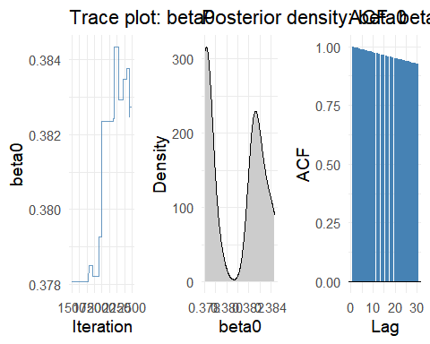

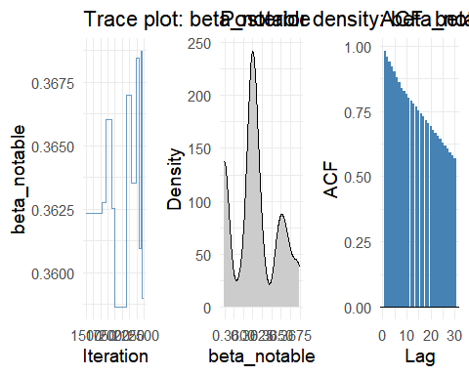

for (var in c("mu_malay", "mu_indian", "mu_chinese")) {  
 plots <- plot_trace_dens_acf(post, var)  
 grid.arrange(grobs = plots, ncol = 3)  
}

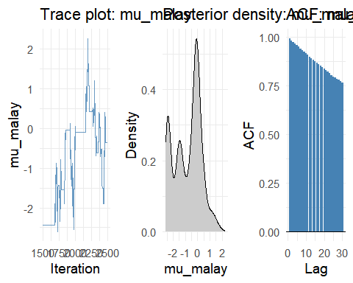

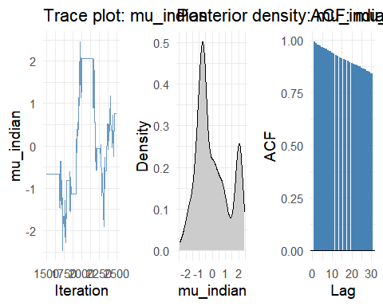

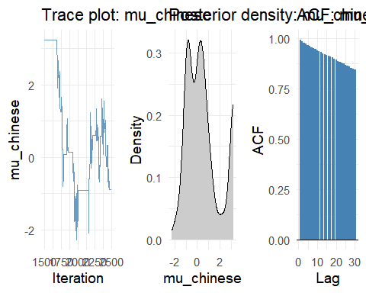

for (var in c("tau_malay", "tau_indian", "tau_chinese")) {  
 plots <- plot_trace_dens_acf(post, var)  
 grid.arrange(grobs = plots, ncol = 3)  
}

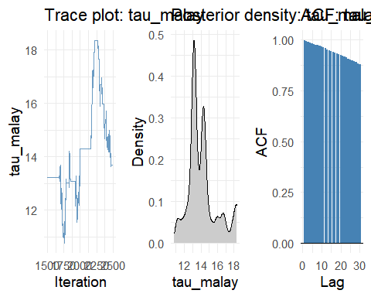

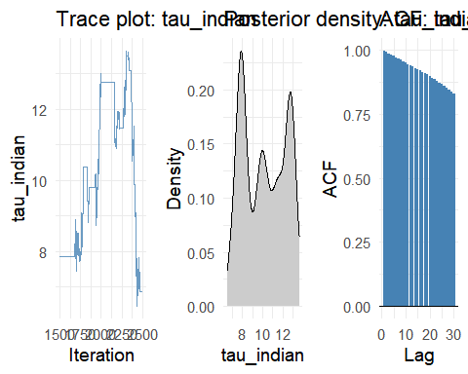

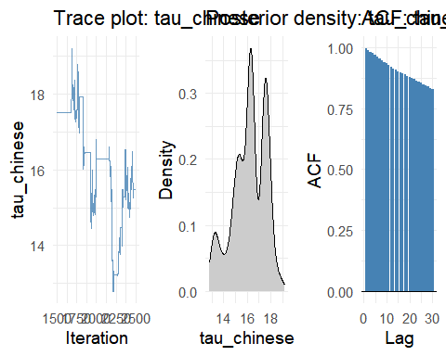

for (r in 1:R) {  
 for (eth in c("malay", "indian", "chinese")) {  
 var <- paste0("beta_", eth, "_r", r)  
 plots <- plot_trace_dens_acf(post, var)  
 grid.arrange(grobs = plots, ncol = 3)  
 }  
}

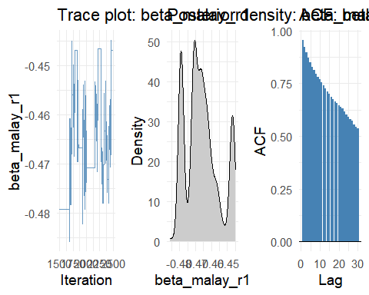

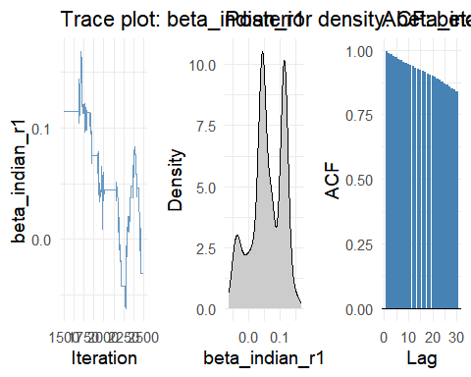

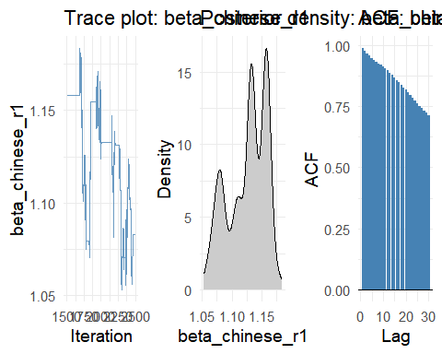

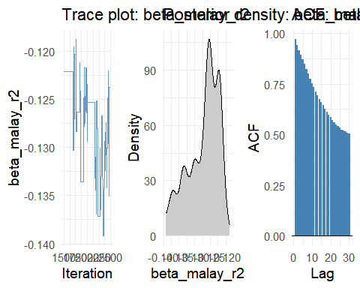

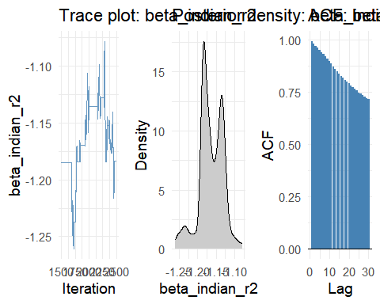

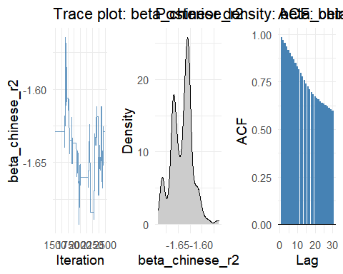

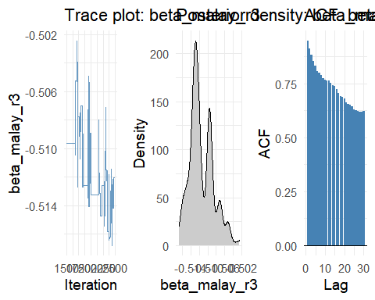

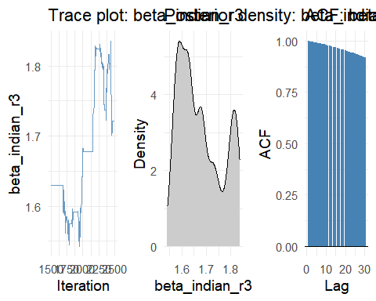

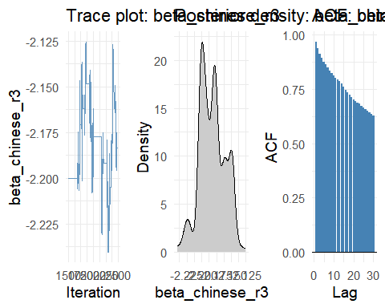

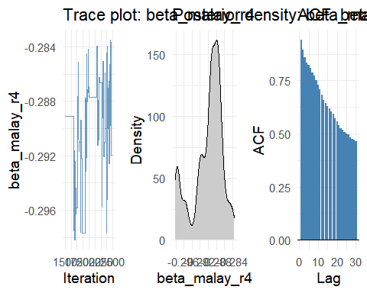

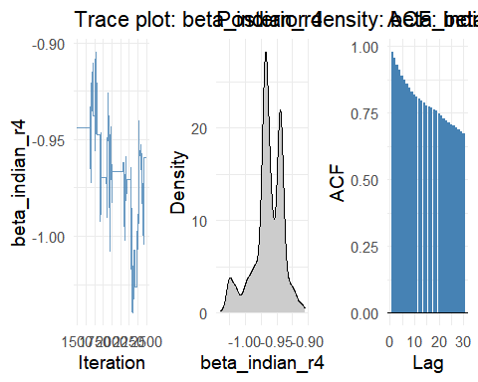

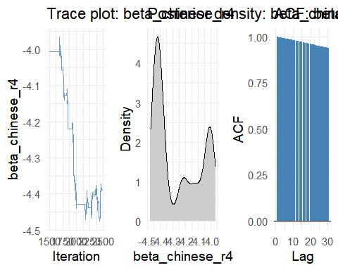

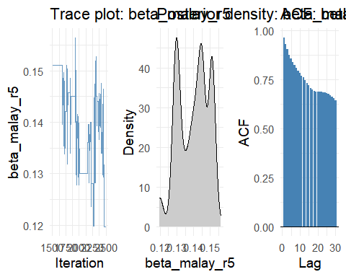

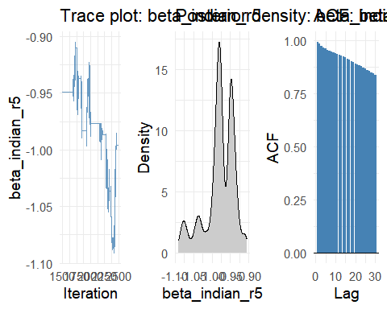

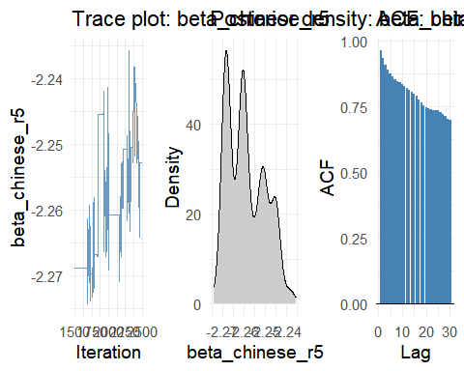

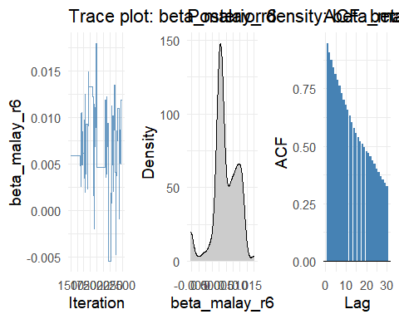

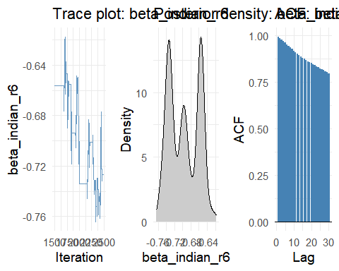

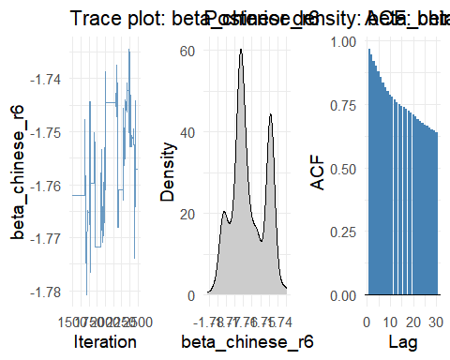

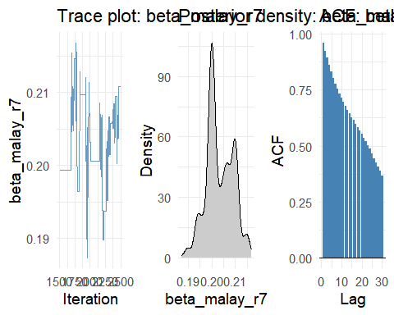

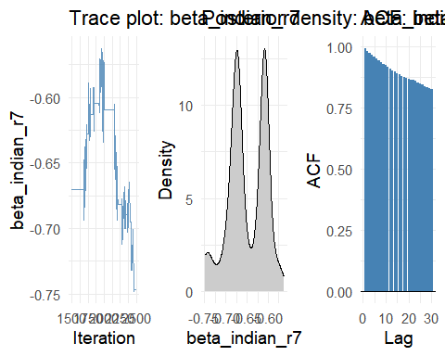

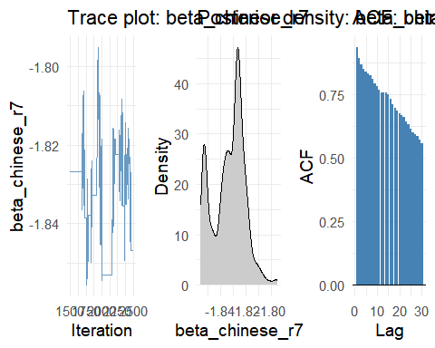

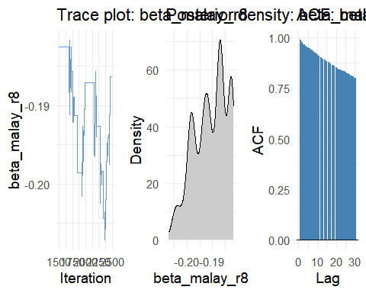

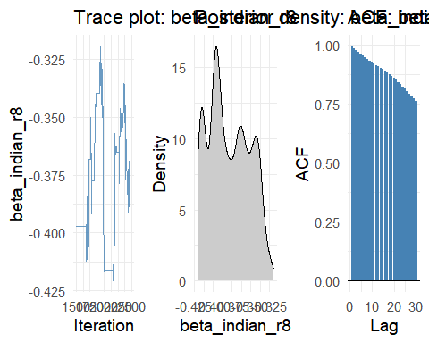

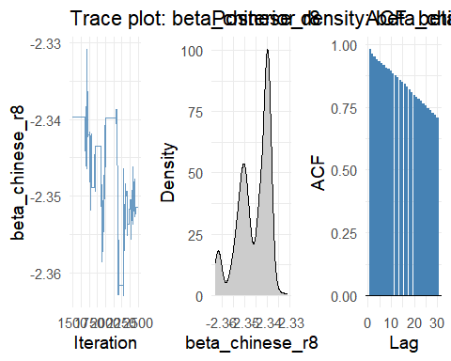

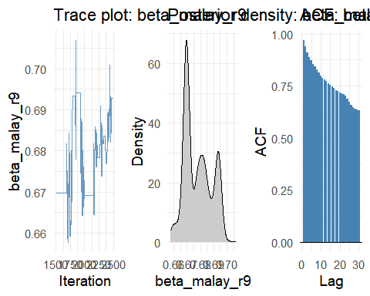

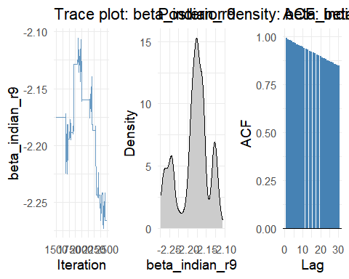

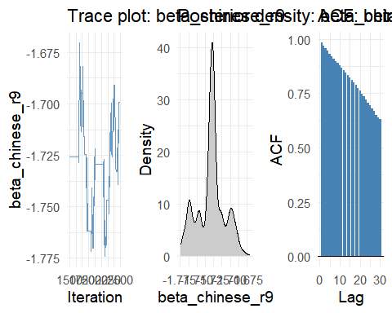

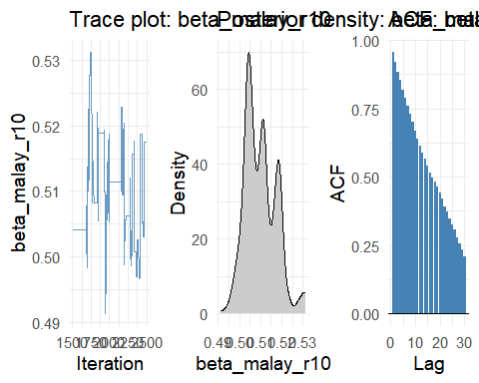

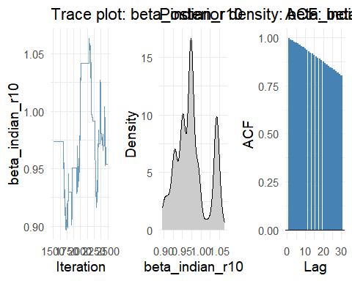

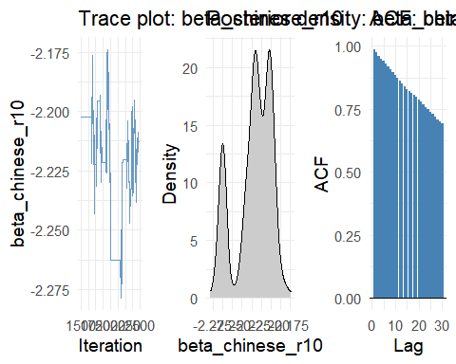

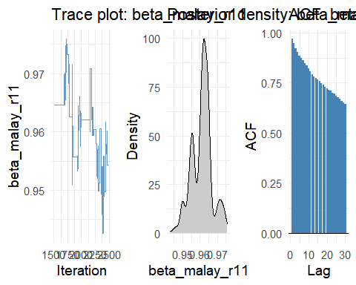

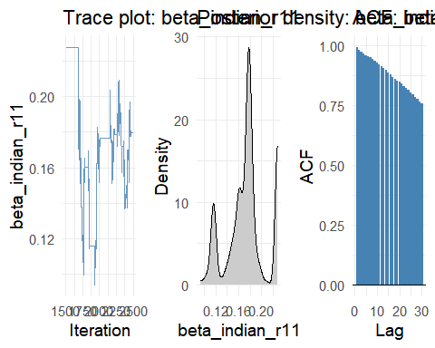

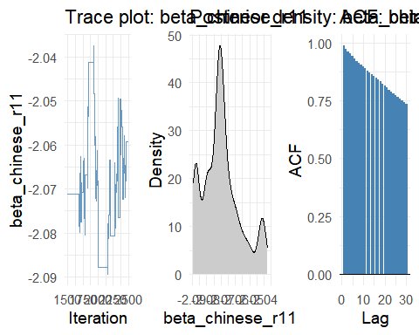

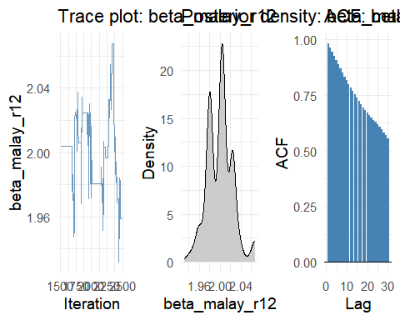

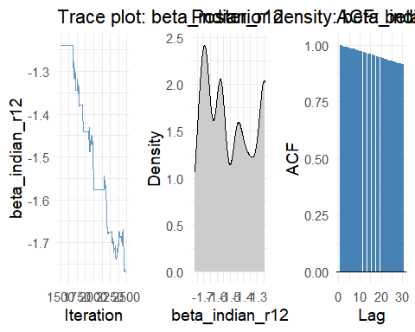

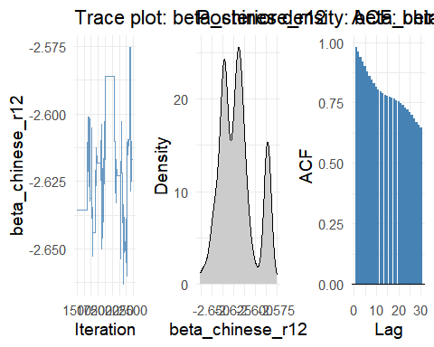

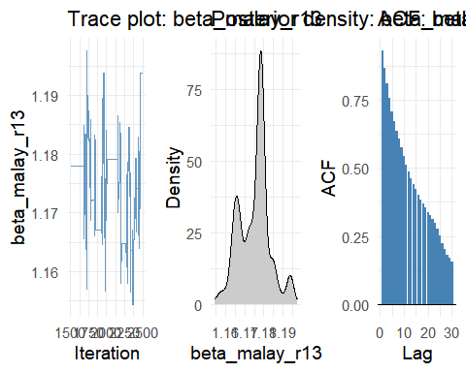

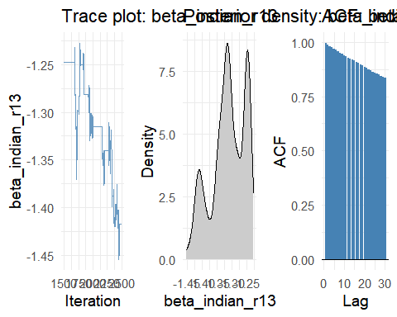

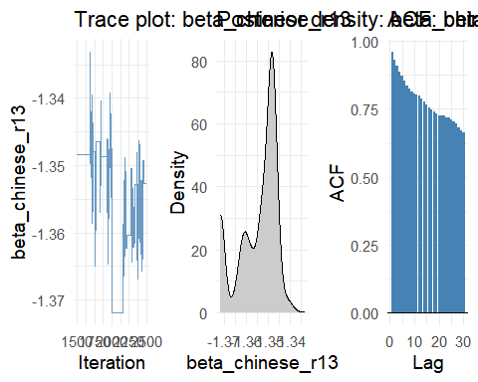

## 7. Posterior Summaries (Mean, SD, 95% Intervals)

posterior_summary <- post %>%  
 summarise(  
 mean_beta0 = mean(beta0),  
 sd_beta0 = sd(beta0),  
 `2.5%_beta0` = quantile(beta0, 0.025),  
 `97.5%_beta0` = quantile(beta0, 0.975),  
   
 mean_beta_notable = mean(beta_notable),  
 sd_beta_notable = sd(beta_notable),  
 `2.5%_beta_notable` = quantile(beta_notable, 0.025),  
 `97.5%_beta_notable` = quantile(beta_notable, 0.975),  
   
 mean_mu_malay = mean(mu_malay),  
 sd_mu_malay = sd(mu_malay),  
 `2.5%_mu_malay` = quantile(mu_malay, 0.025),  
 `97.5%_mu_malay`= quantile(mu_malay, 0.975),  
   
 mean_mu_indian = mean(mu_indian),  
 sd_mu_indian = sd(mu_indian),  
 `2.5%_mu_indian` = quantile(mu_indian, 0.025),  
 `97.5%_mu_indian`= quantile(mu_indian, 0.975),  
   
 mean_mu_chinese = mean(mu_chinese),  
 sd_mu_chinese = sd(mu_chinese),  
 `2.5%_mu_chinese` = quantile(mu_chinese, 0.025),  
 `97.5%_mu_chinese`= quantile(mu_chinese, 0.975),  
   
 across(starts_with("beta_malay_r"), list(mean = ~mean(.), sd = ~sd(.),  
 low_2.5 = ~quantile(., 0.025),  
 hi_97.5 = ~quantile(., 0.975))),  
 across(starts_with("beta_indian_r"), list(mean = ~mean(.), sd = ~sd(.),  
 low_2.5 = ~quantile(., 0.025),  
 hi_97.5 = ~quantile(., 0.975))),  
 across(starts_with("beta_chinese_r"), list(mean = ~mean(.), sd = ~sd(.),  
 low_2.5 = ~quantile(., 0.025),  
 hi_97.5 = ~quantile(., 0.975))),  
 mean_malay_tau = mean(tau_malay),  
 sd_malay_tau = sd(tau_malay),  
 `2.5%_tau_malay` = quantile(tau_malay, 0.025),  
 `97.5%_tau_malay`= quantile(tau_malay, 0.975),  
   
 mean_chinese_tau = mean(tau_chinese),  
 sd_chinese_tau = sd(tau_chinese),  
 `2.5%_tau_chinese` = quantile(tau_chinese, 0.025),  
 `97.5%_tau_chinese`= quantile(tau_chinese, 0.975),  
   
 mean_indian_tau = mean(tau_indian),  
 sd_indian_tau = sd(tau_indian),  
 `2.5%_tau_indian` = quantile(tau_indian, 0.025),  
 `97.5%_tau_indian`= quantile(tau_indian, 0.975),  
 ) %>%  
 pivot_longer(cols = everything(),  
 names_to = "parameter",  
 values_to = "value")  
  
print(posterior_summary, n = 100)

# A tibble: 188 × 2  
 parameter value  
 <chr> <dbl>  
 1 mean_beta0 0.381   
 2 sd_beta0 0.00244  
 3 2.5%_beta0 0.378   
 4 97.5%_beta0 0.384   
 5 mean_beta_notable 0.363   
 6 sd_beta_notable 0.00298  
 7 2.5%_beta_notable 0.359   
 8 97.5%_beta_notable 0.368   
 9 mean_mu_malay -0.804   
 10 sd_mu_malay 1.09   
 11 2.5%_mu_malay -2.44   
 12 97.5%_mu_malay 1.08   
 13 mean_mu_indian 0.00315  
 14 sd_mu_indian 1.22   
 15 2.5%_mu_indian -1.91   
 16 97.5%_mu_indian 2.07   
 17 mean_mu_chinese 0.582   
 18 sd_mu_chinese 1.52   
 19 2.5%_mu_chinese -1.53   
 20 97.5%_mu_chinese 3.22   
 21 beta_malay_r1_mean -0.466   
 22 beta_malay_r1_sd 0.0103   
 23 beta_malay_r1_low_2.5 -0.479   
 24 beta_malay_r1_hi_97.5 -0.447   
 25 beta_malay_r2_mean -0.127   
 26 beta_malay_r2_sd 0.00496  
 27 beta_malay_r2_low_2.5 -0.137   
 28 beta_malay_r2_hi_97.5 -0.120   
 29 beta_malay_r3_mean -0.511   
 30 beta_malay_r3_sd 0.00282  
 31 beta_malay_r3_low_2.5 -0.516   
 32 beta_malay_r3_hi_97.5 -0.505   
 33 beta_malay_r4_mean -0.290   
 34 beta_malay_r4_sd 0.00370  
 35 beta_malay_r4_low_2.5 -0.298   
 36 beta_malay_r4_hi_97.5 -0.284   
 37 beta_malay_r5_mean 0.140   
 38 beta_malay_r5_sd 0.00903  
 39 beta_malay_r5_low_2.5 0.120   
 40 beta_malay_r5_hi_97.5 0.151   
 41 beta_malay_r6_mean 0.00706  
 42 beta_malay_r6_sd 0.00458  
 43 beta_malay_r6_low_2.5 -0.00546  
 44 beta_malay_r6_hi_97.5 0.0135   
 45 beta_malay_r7_mean 0.203   
 46 beta_malay_r7_sd 0.00563  
 47 beta_malay_r7_low_2.5 0.194   
 48 beta_malay_r7_hi_97.5 0.215   
 49 beta_malay_r8_mean -0.191   
 50 beta_malay_r8_sd 0.00635  
 51 beta_malay_r8_low_2.5 -0.204   
 52 beta_malay_r8_hi_97.5 -0.183   
 53 beta_malay_r9_mean 0.678   
 54 beta_malay_r9_sd 0.0100   
 55 beta_malay_r9_low_2.5 0.661   
 56 beta_malay_r9_hi_97.5 0.694   
 57 beta_malay_r10_mean 0.510   
 58 beta_malay_r10_sd 0.00740  
 59 beta_malay_r10_low_2.5 0.498   
 60 beta_malay_r10_hi_97.5 0.528   
 61 beta_malay_r11_mean 0.961   
 62 beta_malay_r11_sd 0.00586  
 63 beta_malay_r11_low_2.5 0.950   
 64 beta_malay_r11_hi_97.5 0.973   
 65 beta_malay_r12_mean 2.00   
 66 beta_malay_r12_sd 0.0246   
 67 beta_malay_r12_low_2.5 1.95   
 68 beta_malay_r12_hi_97.5 2.07   
 69 beta_malay_r13_mean 1.18   
 70 beta_malay_r13_sd 0.00804  
 71 beta_malay_r13_low_2.5 1.16   
 72 beta_malay_r13_hi_97.5 1.19   
 73 beta_indian_r1_mean 0.0601   
 74 beta_indian_r1_sd 0.0511   
 75 beta_indian_r1_low_2.5 -0.0423   
 76 beta_indian_r1_hi_97.5 0.130   
 77 beta_indian_r2_mean -1.16   
 78 beta_indian_r2_sd 0.0325   
 79 beta_indian_r2_low_2.5 -1.24   
 80 beta_indian_r2_hi_97.5 -1.11   
 81 beta_indian_r3_mean 1.68   
 82 beta_indian_r3_sd 0.0859   
 83 beta_indian_r3_low_2.5 1.57   
 84 beta_indian_r3_hi_97.5 1.82   
 85 beta_indian_r4_mean -0.964   
 86 beta_indian_r4_sd 0.0239   
 87 beta_indian_r4_low_2.5 -1.03   
 88 beta_indian_r4_hi_97.5 -0.923   
 89 beta_indian_r5_mean -0.979   
 90 beta_indian_r5_sd 0.0395   
 91 beta_indian_r5_low_2.5 -1.08   
 92 beta_indian_r5_hi_97.5 -0.917   
 93 beta_indian_r6_mean -0.697   
 94 beta_indian_r6_sd 0.0361   
 95 beta_indian_r6_low_2.5 -0.752   
 96 beta_indian_r6_hi_97.5 -0.642   
 97 beta_indian_r7_mean -0.650   
 98 beta_indian_r7_sd 0.0434   
 99 beta_indian_r7_low_2.5 -0.747   
100 beta_indian_r7_hi_97.5 -0.580   
# ℹ 88 more rows